Milestone 5 – Completed Functionalities with Screenshots
FOR

BI DASHBOARD WEB APPLICATION
SUBMITTED TO
IVTECH COMPUTER SYSTEMS LLC

Version: 1.0

30th July 2025

Prepared By:
SPEC INDIA
Revision History

Date | Version | Author | Created / Updated / Reviewed / Verified / Approved By
30-07-2025 | 1.0 | Parth Jotangiya | - Initial Draft
30-07-2025 | 1.0 | Yaman Kavishwar | - Reviewed and approved

Table of Contents
Contents
1. Introduction 4
1.1. Items in the Scope 4
2. Detailed Screenshots for Each Functionality 5
2.1 BI Dashboard Web Application - Dashboard Widgets 5
2.2 Export Reports 38
2.3 Installable Package 39
2.4 Settings 40
2.5 Configuration – Backup & Restore Page 44
2.6 Alexa Integration 46
2.7 Other Key Features 46

Introduction

- This document serves as a comprehensive summary of all the functionalities that were planned, developed, and completed as part of Milestone 5 for the BI Dashboard Web Application project. It includes detailed information about each feature, covering its objective, scope, and expected behavior.
- Each functionality is thoroughly described and supported with annotated screenshots to visually demonstrate successful implementation. These visual validations help in ensuring that the delivered features align with the requirements and offer clarity for future reference, testing, or client verification.

Items in the Scope

Sr. No | Functionality Title | Description | Status
1 | Dashboard Widgets | - Implementation of widgets under the Vehicle, Factory categories.  - Floor Plan widget.  - Heat Map widgets.  - The "1st option with 2×1" in the People & Vehicle In & Out widget | Completed
2 | Export Reports | - Export Reports to PDF/excel/csv. | Completed
3 | Installable Package | - Creating an Installable Package. | Completed
4 | Settings | - License Management.  - Multisite Setup  - General  - SMTP Setup  - Report Scheduler  - FTP Setup  - Upload SSL Certificate  - Operational Time | Completed
5 | Configuration | - Backup and restore. | Completed
6 | Alexa Integration | - Integration with Alexa, so that when the Alexa device is connected, it will open the specific widget on voice command. | Completed
7 | Other key features | - Camera should support multilane while configuring it on the specific zone.  - Show heat maps (Heat Map widget).  - Event Logs page | Completed

Detailed Screenshots for Each Functionality

BI Dashboard Web Application - Dashboard Widgets

The BI Dashboard Web Application is a platform designed with key foundational modules to support user access control and device management. It includes a secure, credential-based user authentication system, and a comprehensive role and permission management structure that allows super users to create and manage sub-users with varying levels of access based on assigned roles.

Additionally, core functionalities have been developed for camera and AI box management, enabling authorized users to add, update, or remove devices. The system features floor plan and zone management, allowing users to define layouts and associate specific areas with camera zones. A camera-to-zone configuration module has also been implemented to map devices to their respective zones. Furthermore, the application supports multi-site management for deployments across multiple locations. Users can track and acknowledge generated events, configure system settings, and customize their dashboard by adding or removing widgets as needed.

Here is the link of created Figma Design for BI Dashboard Web Application:
- Light Theme: Click Here
- Dark Theme: Click Here

IMPORTANT NOTE:

Milestone 5 includes the delivery of the following features:

- Implementation of widgets under the
  - Vehicle category:
    - Vehicle In & Out
    - Vehicle Count by Type
    - Vehicle in Wrong Direction
    - Vehicle U Turn Detection
    - Pedestrian Detection
    - Average Vehicle Counting
    - Vehicle Queue Analysis
    - Stopped Vehicle Count
    - Vehicle Turning Movement Count
    - Speed Violation by Vehicle
    - Traffic Jam by Day
  - Factory category:
    - Counting for Forklift
    - Queue Events for Forklift
    - Factory Blocked Exit Detection
    - Detect Forklifts
    - Forklift Speed Detection
  - Floor Plan
  - Heatmap Widgets
    - People Counting Heatmap
    - Shopping Cart Heatmap
    - Vehicle Detection Heatmap
    - Forklift Heatmap

1) Vehicle category - Vehicle In & Out

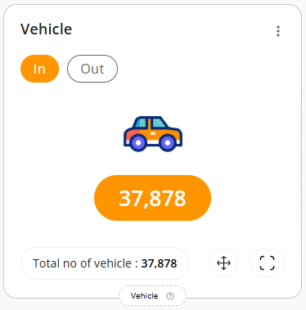
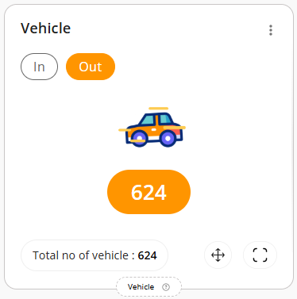
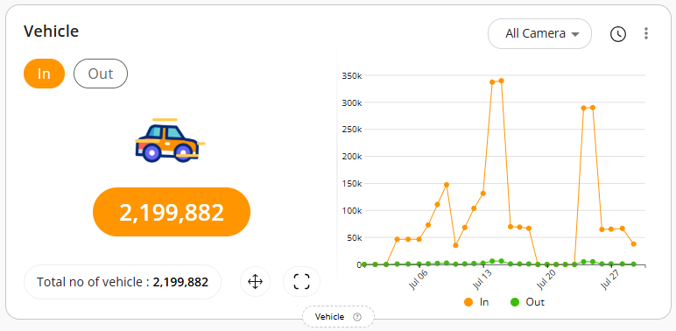
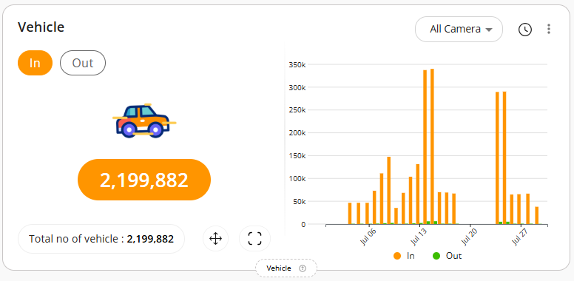
2) Vehicle category - Vehicle Count by Type

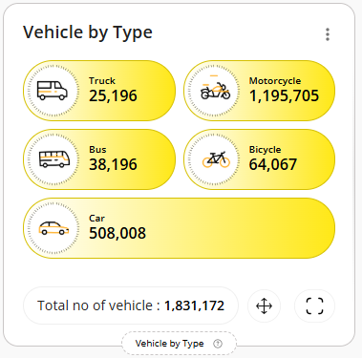
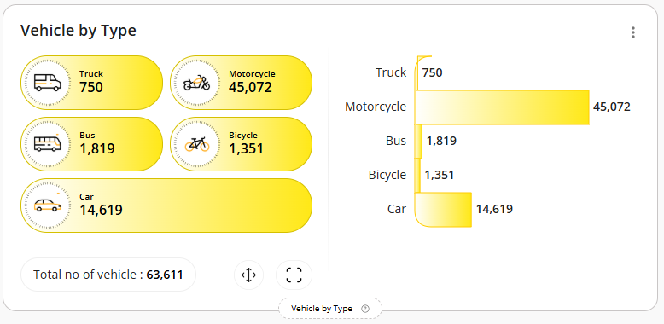
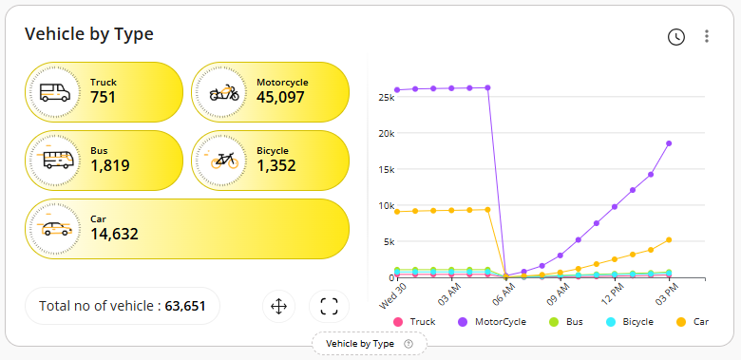
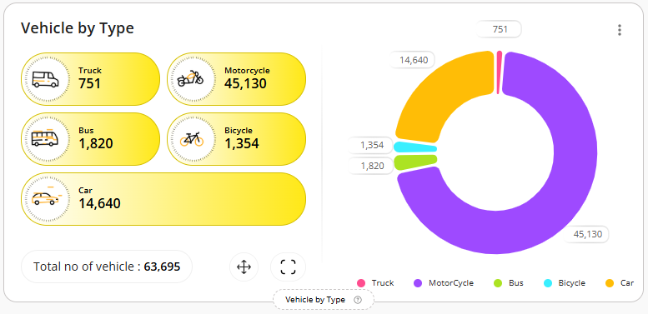

3) Vehicle category - Vehicle in Wrong Direction

- Currently, we are not receiving any events for this. As a result, you may not see any data displayed in the widgets below.

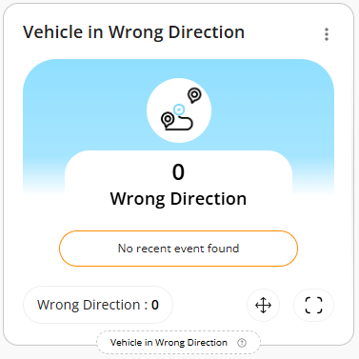
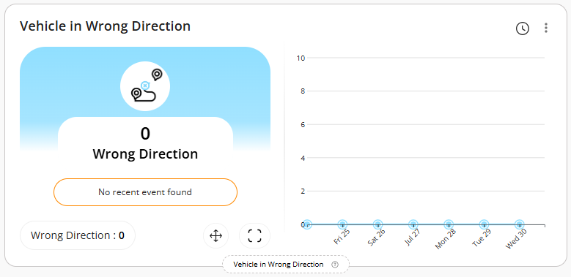
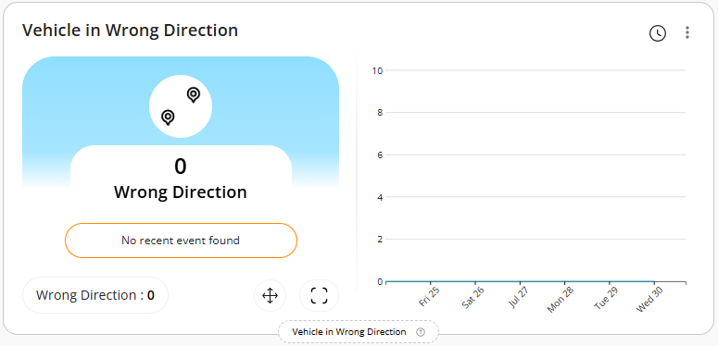
4) Vehicle Category- Vehicle U Turn Detection

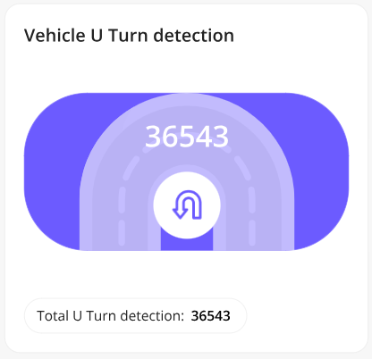
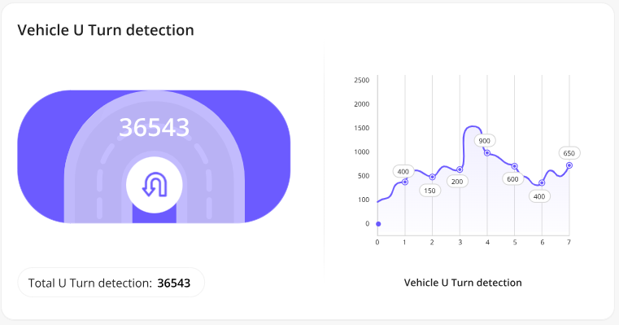
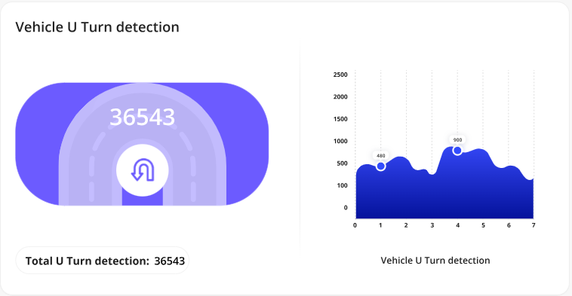

5) Vehicle Category- Pedestrian Detection

- Currently, we are not receiving any events for this. As a result, you may not see any data displayed in the widgets below.

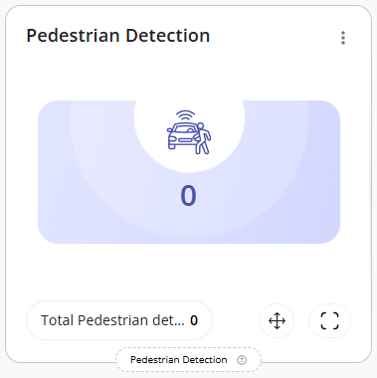
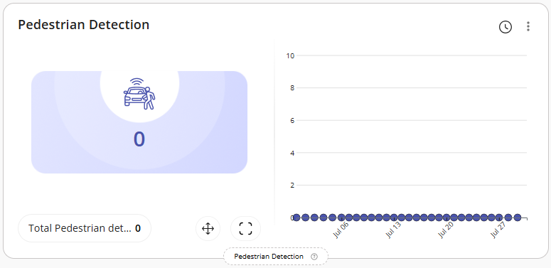
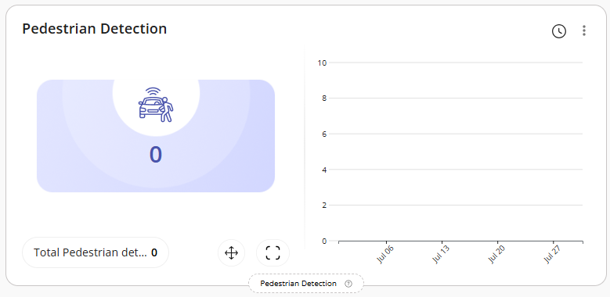

6) Vehicle Category- Average Vehicle Counting

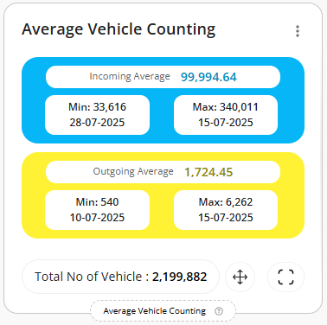
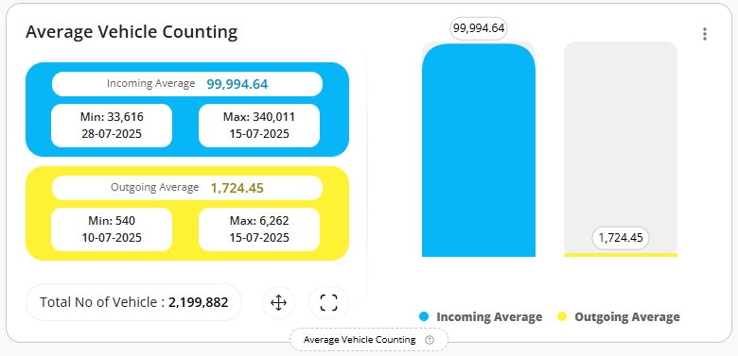
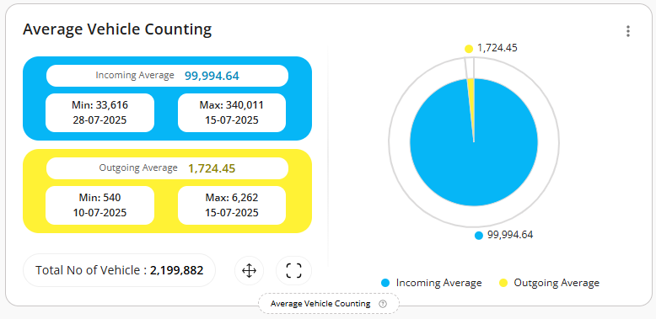
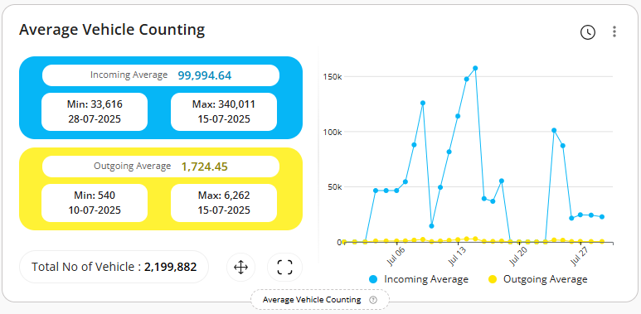
7) Vehicle Category- Vehicle Queue Analysis

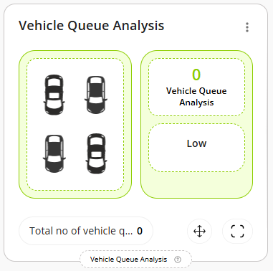
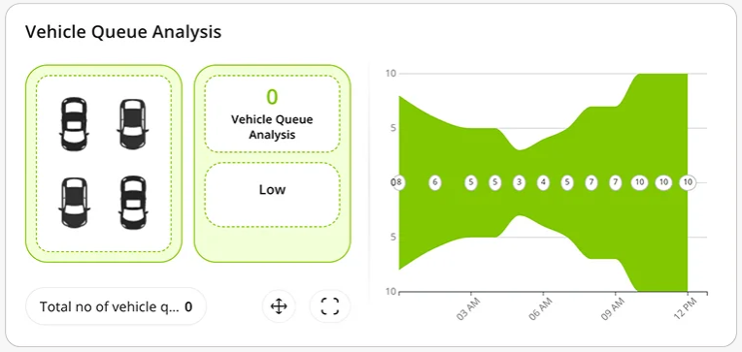
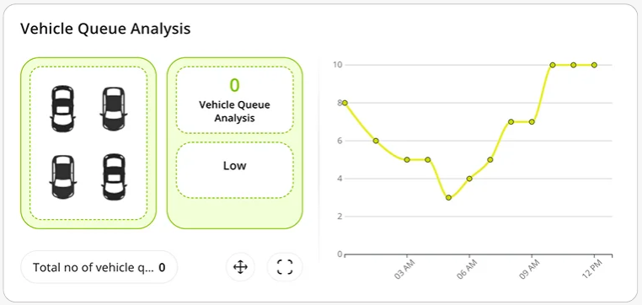
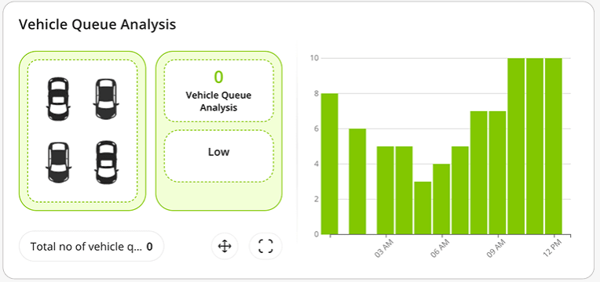
8) Vehicle Category- Stopped Vehicle Count

- Currently, we are not receiving any events for this. As a result, you may not see any data displayed in the widgets below.
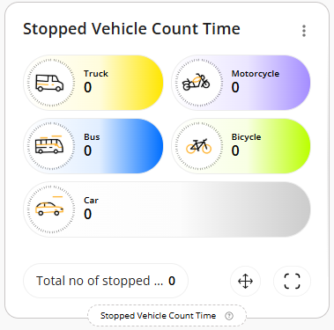
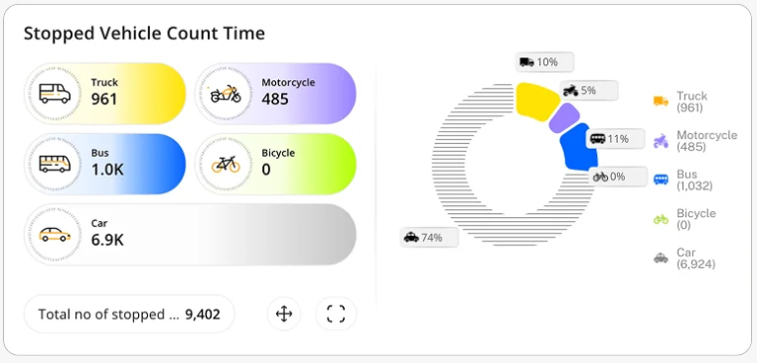
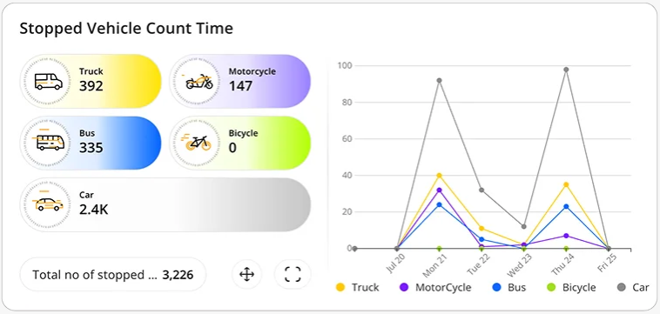
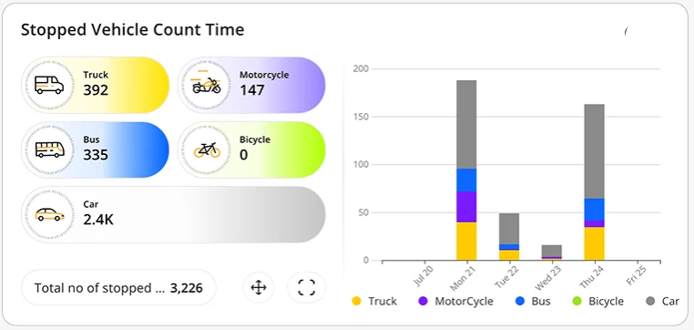

9) Vehicle Category- Vehicle Turning Movement Count

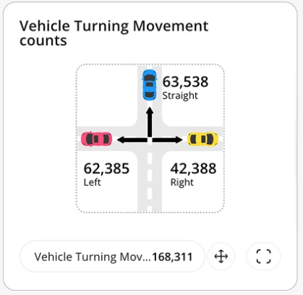
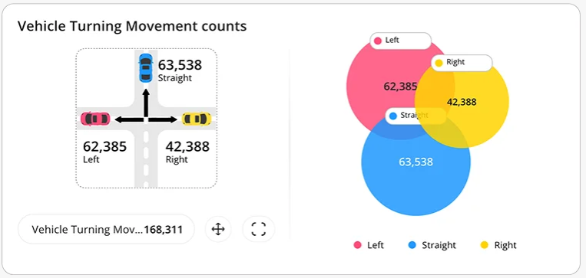
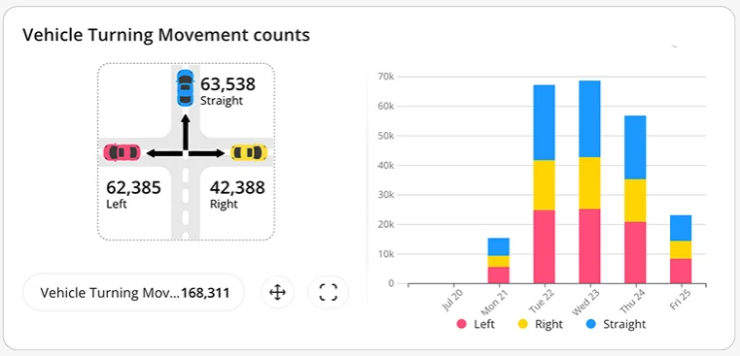
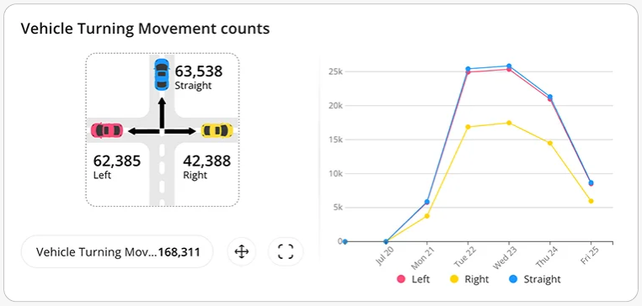
10) Vehicle Category- Speed Violation by Vehicle

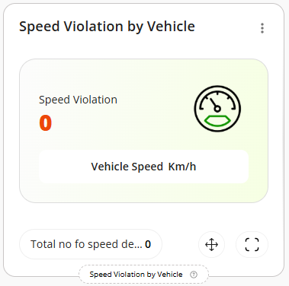
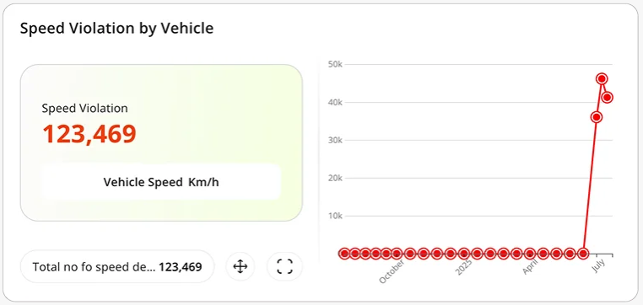
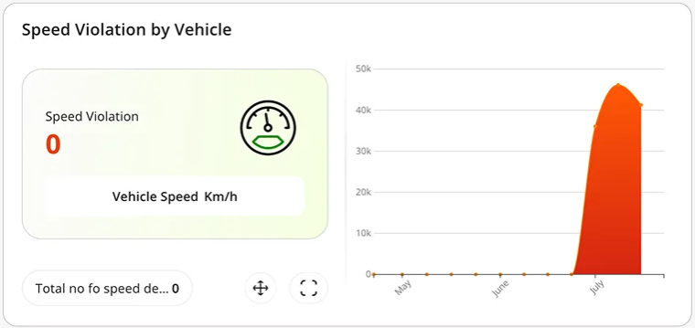
11) Vehicle Category- Traffic Jam by Day

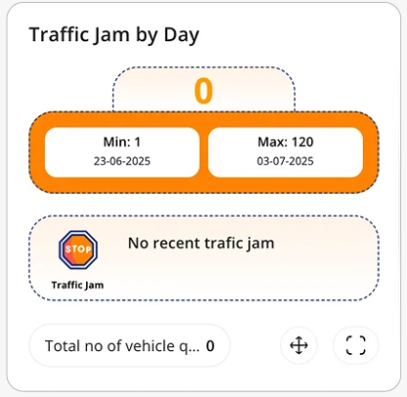
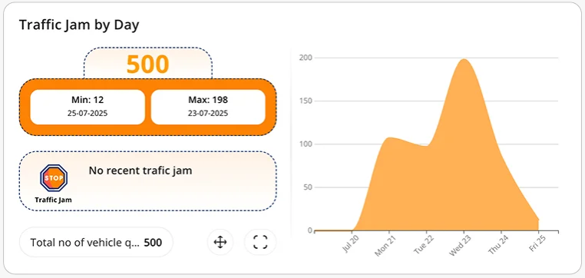
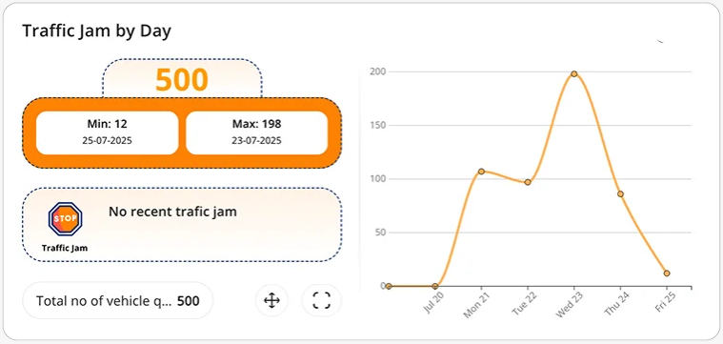
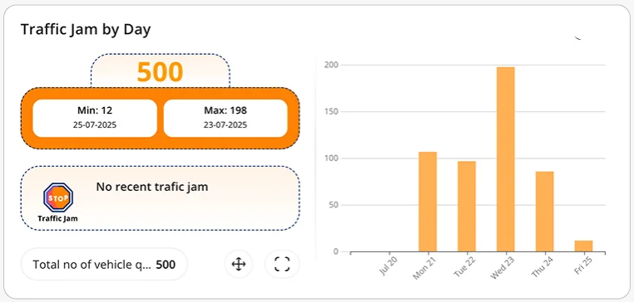
12) Factory Category- Counting for Forklift

- Currently, we are not receiving any events for this. As a result, you may not see any data displayed in the widgets below.

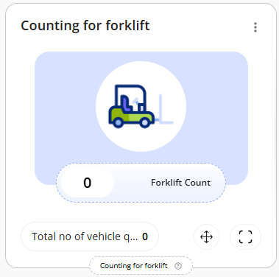
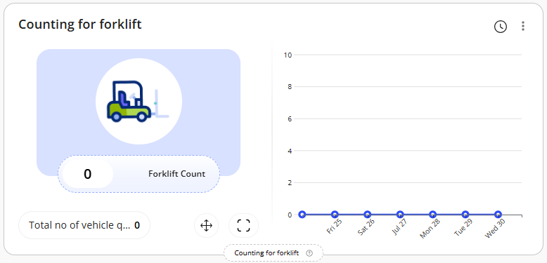
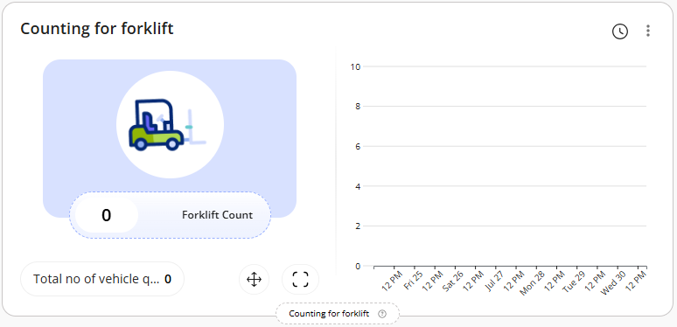
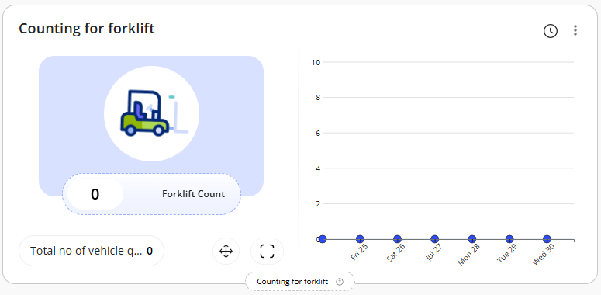
13) Factory Category- Queue Events for Forklift

- Currently, we are not receiving any events for this. As a result, you may not see any data displayed in the widgets below.
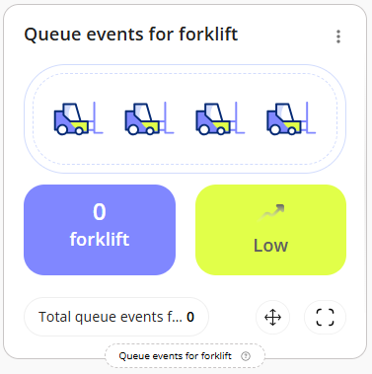
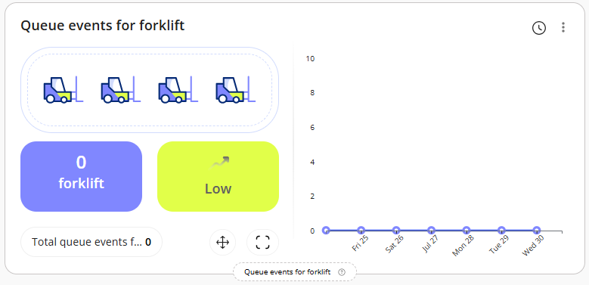
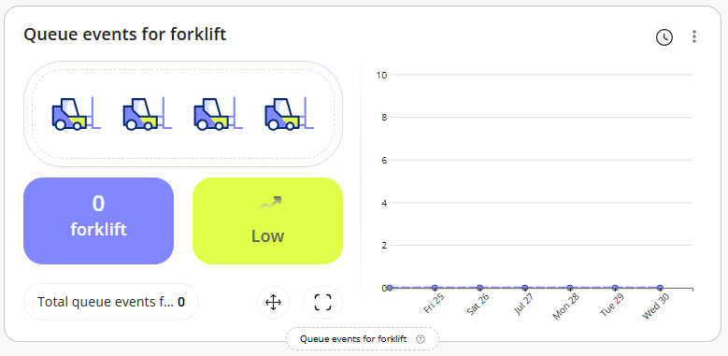
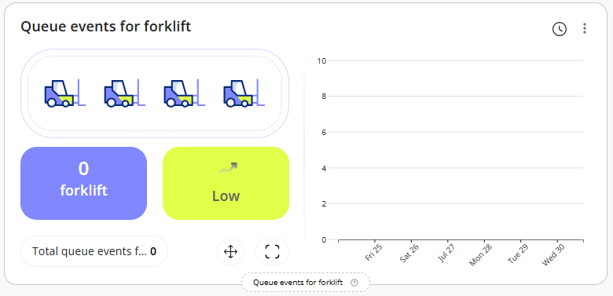
14) Factory Category- Factory Blocked Exit Detection

- Currently, we are not receiving any events for this. As a result, you may not see any data displayed in the widgets below.
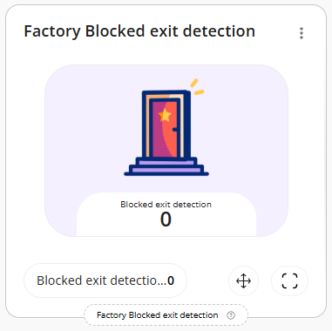
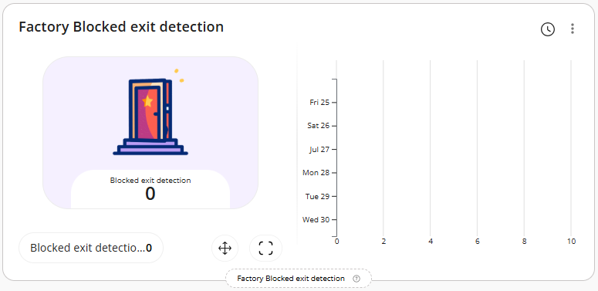
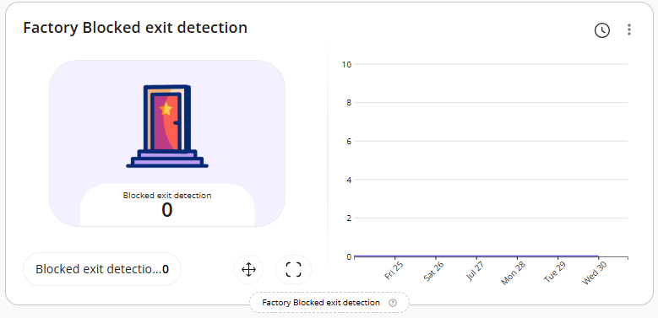
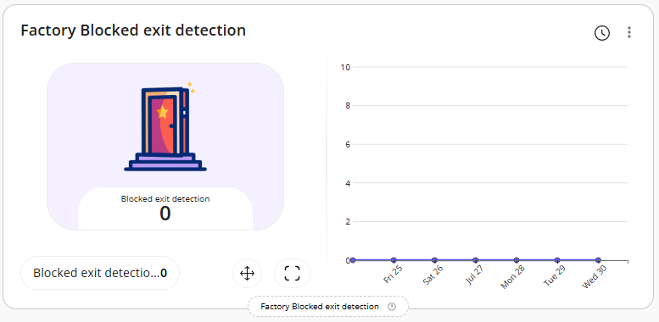
15) Factory Category- Detect Forklifts

- Currently, we are not receiving any events for this. As a result, you may not see any data displayed in the widgets below.
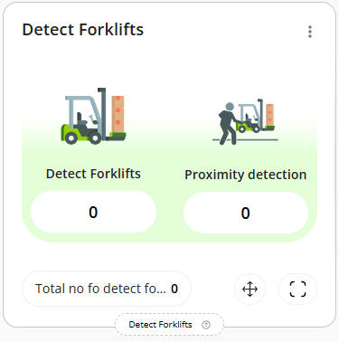
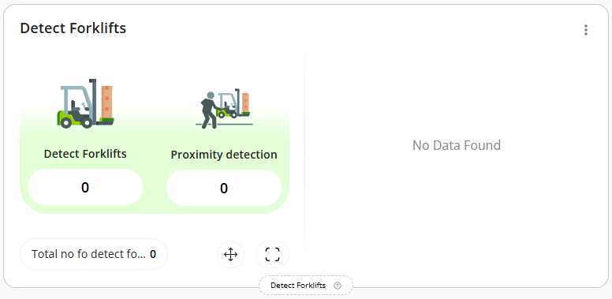
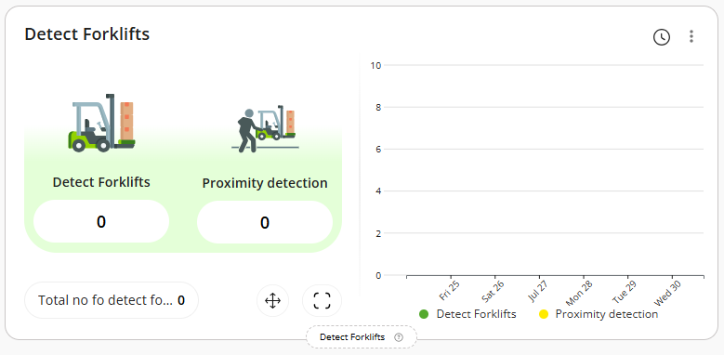
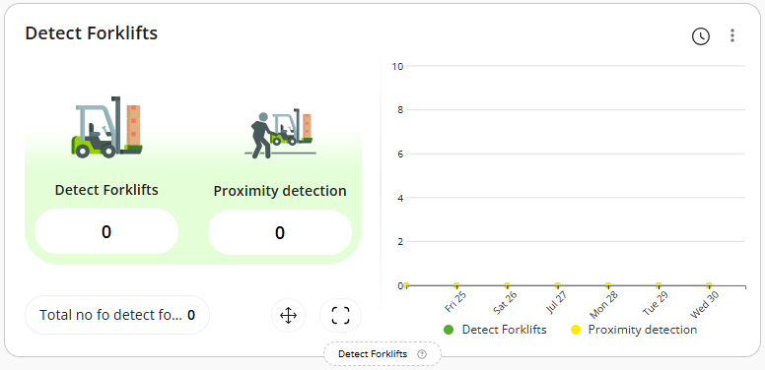
16) Factory Category- Forklift Speed Detection

- Currently, we are not receiving any data related to shopping cart from the camera APIs. As a result, you may not see any data displayed in the widgets below.
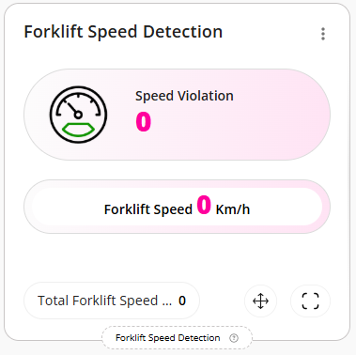
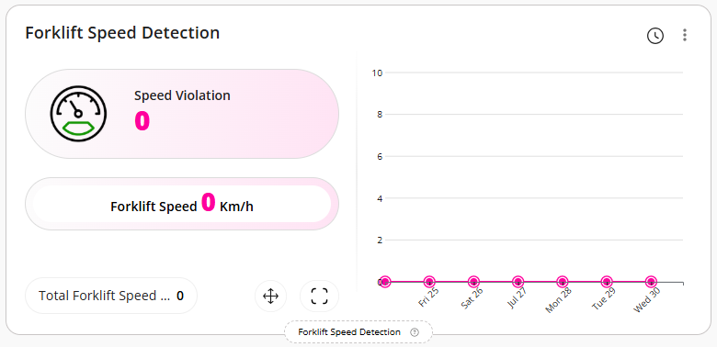
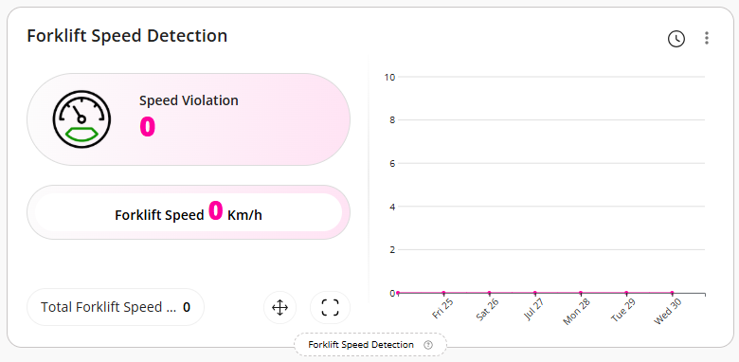
17) Floor Plan

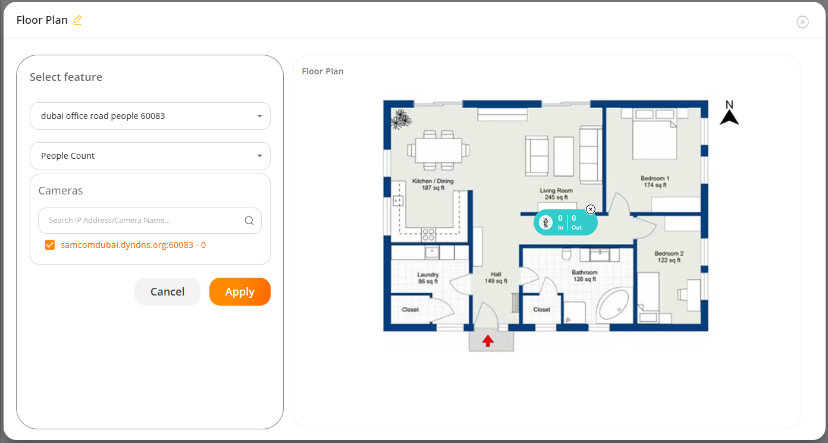
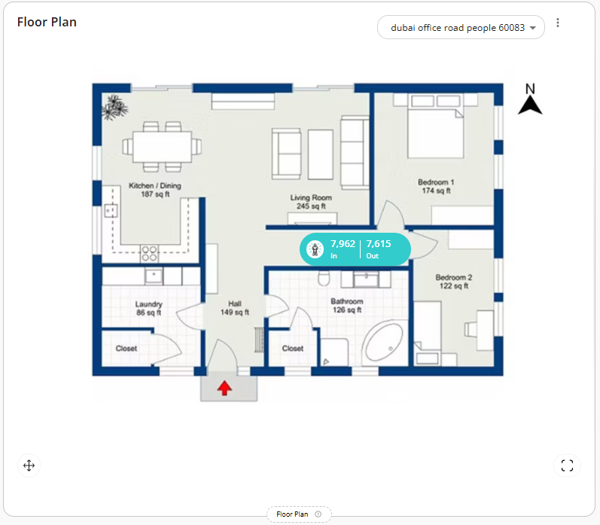
18) Heatmap Widgets - People Counting Heatmap

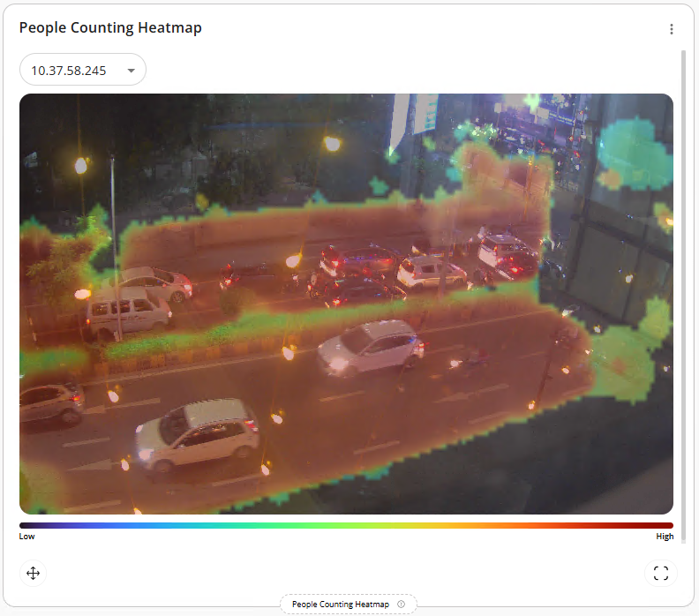

19) Heatmap Widgets - Shopping Cart Heatmap

- Currently, we are not receiving proper data from the API, which is why we are unable to capture a screenshot of these widgets. However, please be assured that the functionality has already been developed and was showcased to the team during the internal demo call.

20) Heatmap Category- Vehicle Detection Heatmap

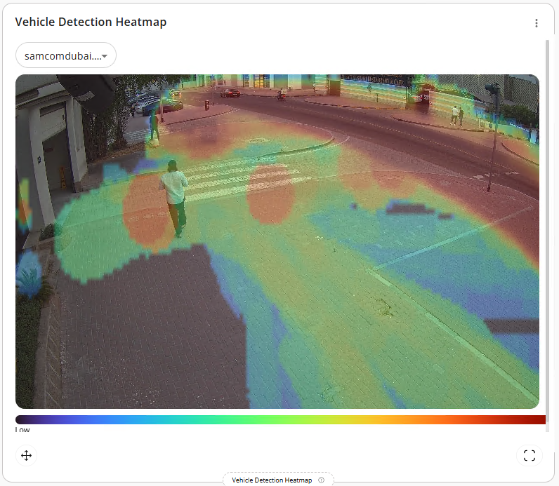
21) Heatmap Category- Forklift Heatmap

- Currently, we are not receiving proper data from the API, which is why we are unable to capture a screenshot of these widgets. However, please be assured that the functionality has already been developed and was showcased to the team during the internal demo call.

Export Reports

The system allows authorized users to export the report as a PDF or CSV file.

Users can export the report from two different locations:

- Export option available within the specific widget:
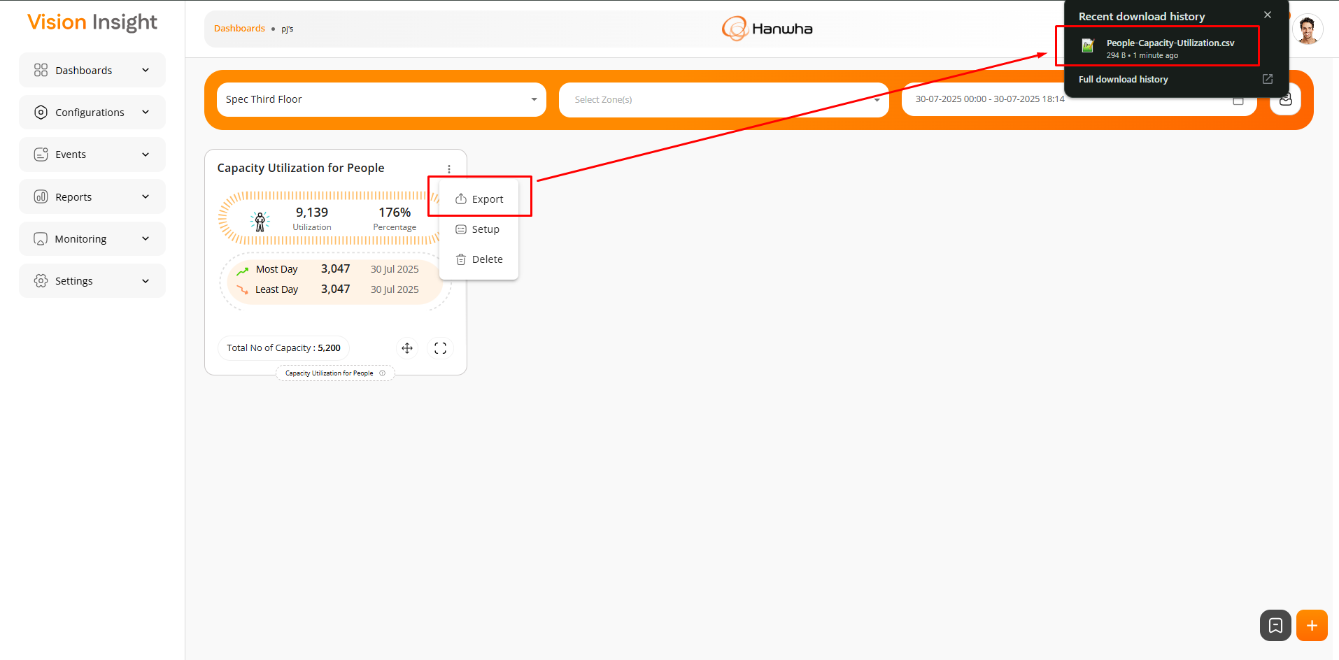
- Export option available in the Advanced Reporting section:
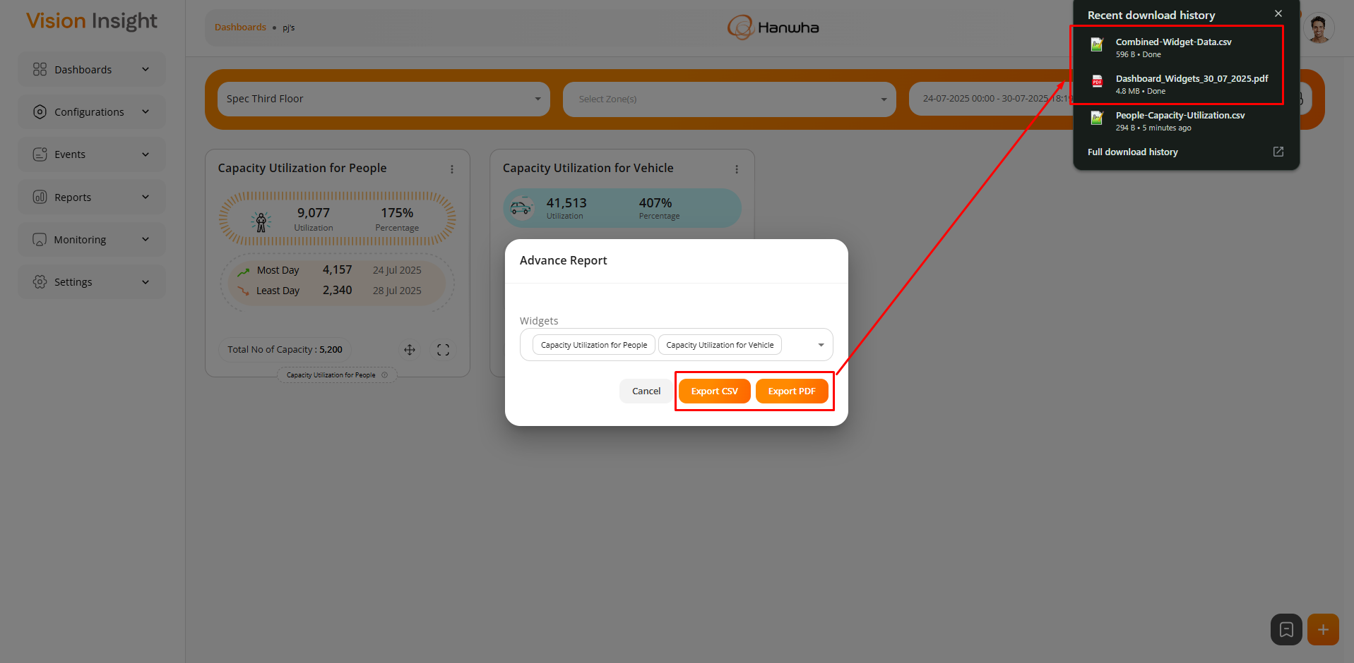

Installable Package

This will allow users to install the entire application in just a few steps.

The installable package will automatically set up all necessary configurations and dependencies on a local Windows machine and deploy the application to the local IIS. As a result, the application will be accessible within the local machine or over the local LAN network only.

Below is the folder structure for the Installable Package:
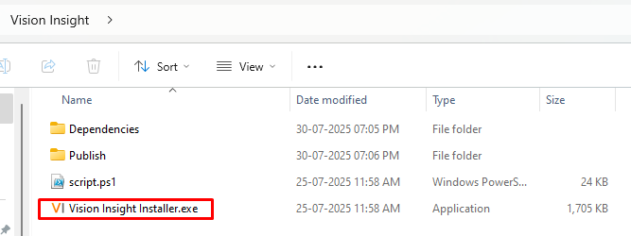

NOTE: The highlighted file is the main installer. The user simply needs to run this file and follow the predefined steps. Once completed, the environment will be ready on the local machine.

Settings

This main menu will include following items in it:
- Manage Users – this has already been included in the Milestone 3 report. Kindly refer to it.
- Role & Permissions – this has already been included in the Milestone 3 report. Kindly refer. to it.
- Multisite Setup
- General
  - SMTP Setup
  - Report Scheduler
  - FTP Setup
  - Upload Your Logo – this has already been included in the Milestone 3 report. Kindly refer to it.
  - Upload SSL Certificate
  - Operational Time
  - Google Map Key – this has already been included in the Milestone 3 report. Kindly refer to it.
- License

Multisite Setup:

This feature allows users to manage multiple sites up to two hierarchical levels (e.g., Child Site > Sub Child Site).
Please find the screenshots below for reference:
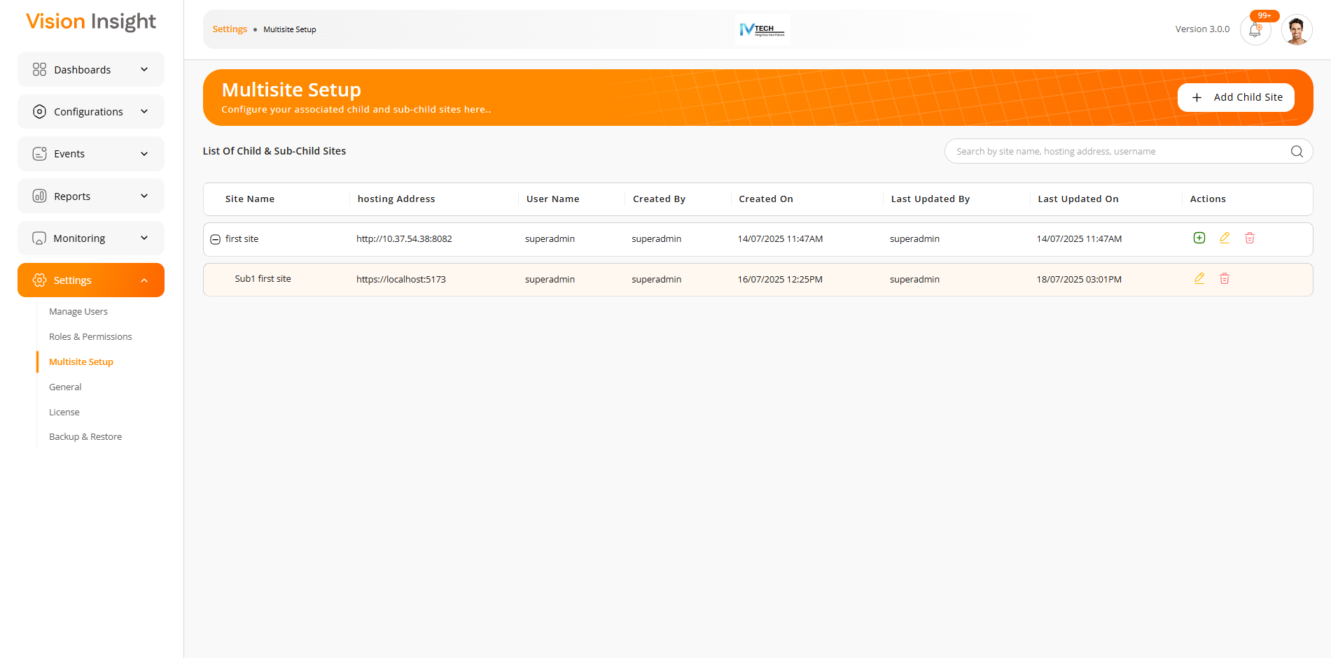
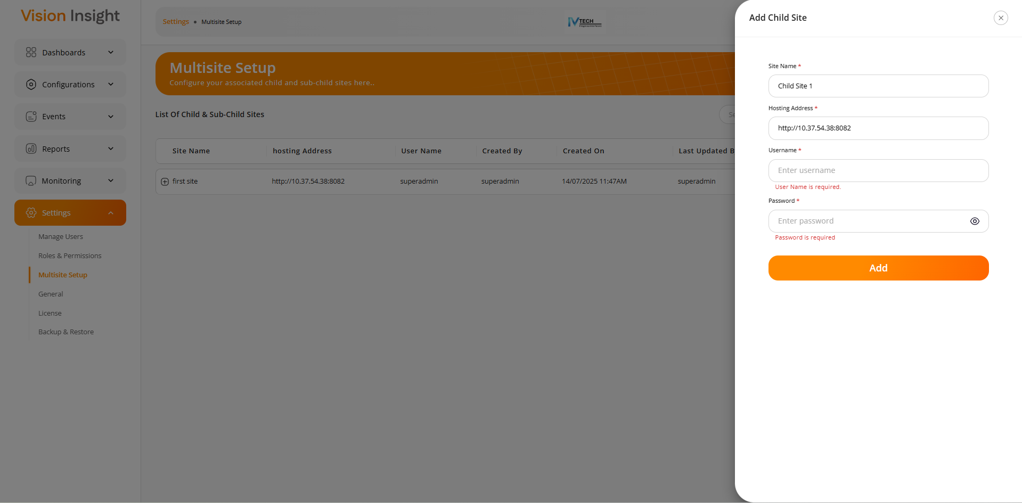
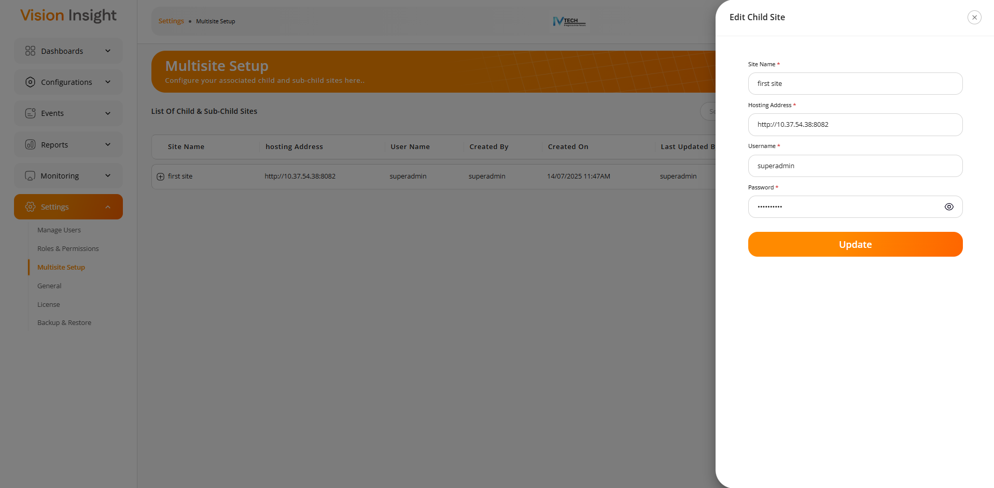
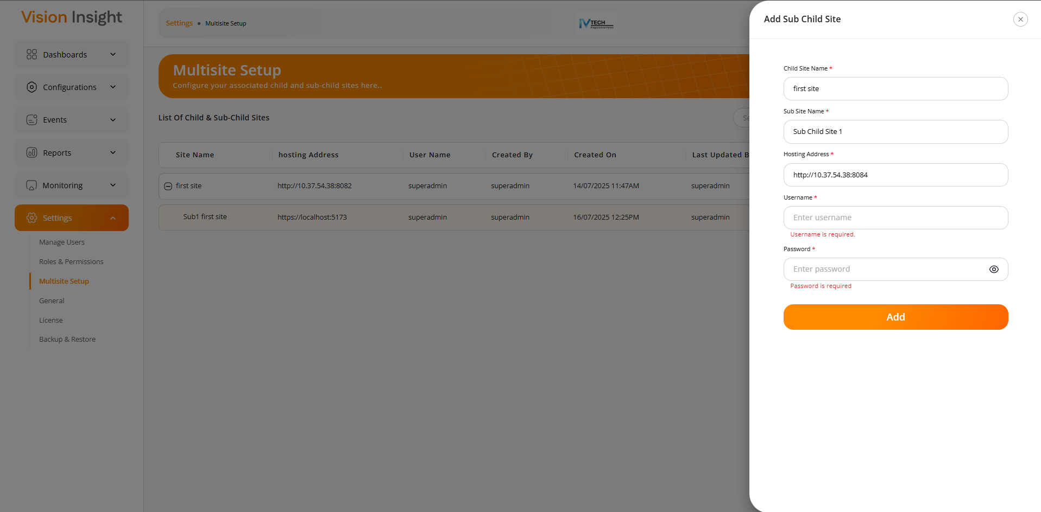
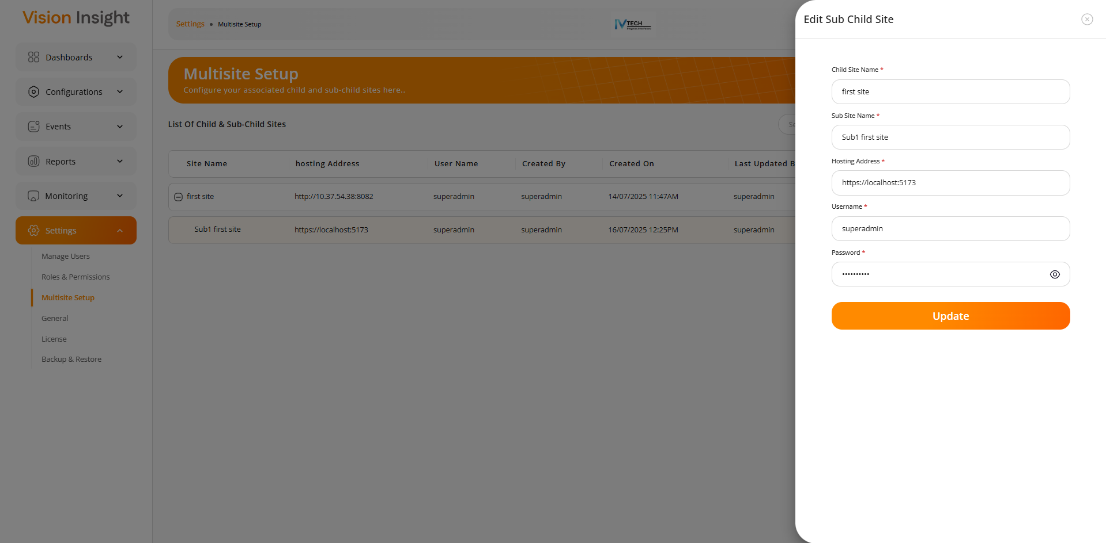

General - SMTP Setup & Report Scheduler:

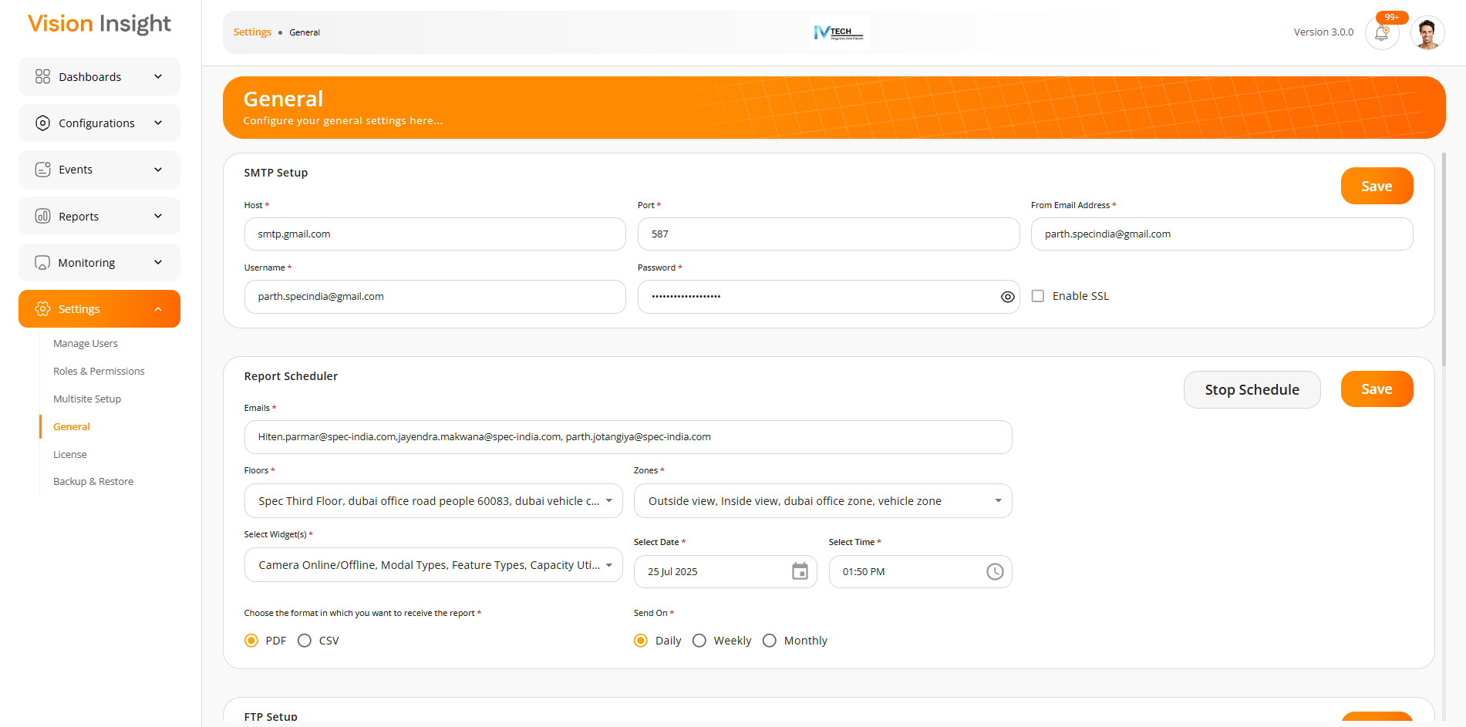
General - FTP Setup & Upload Your Logo:

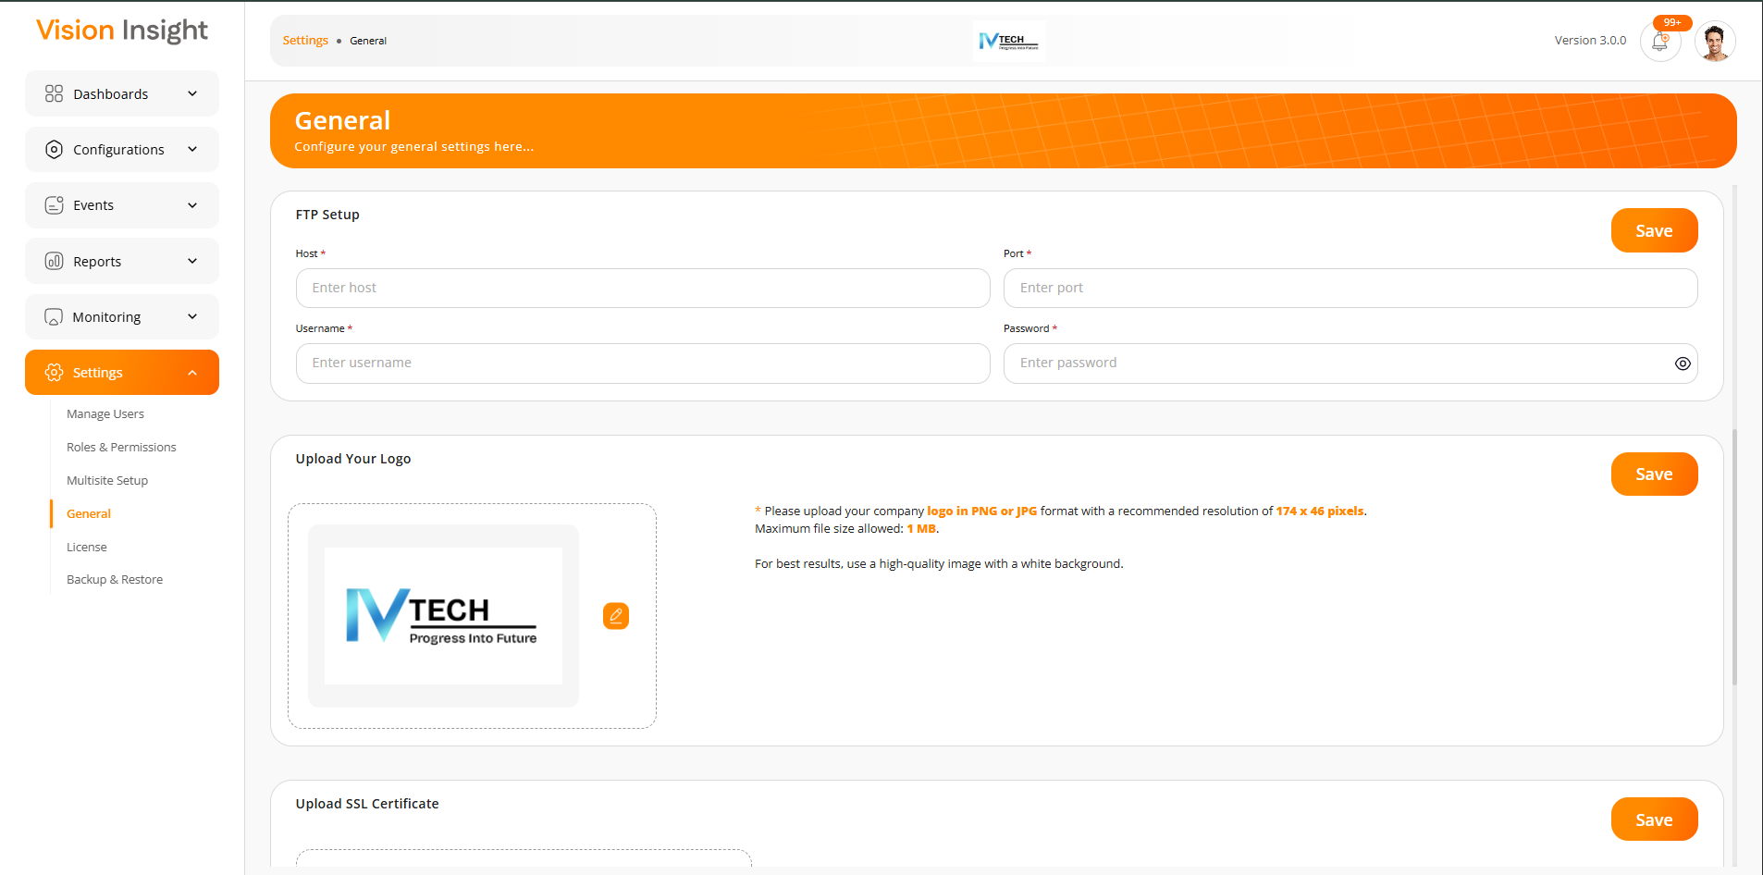
General - Upload SSL Certificate & Operational Time:

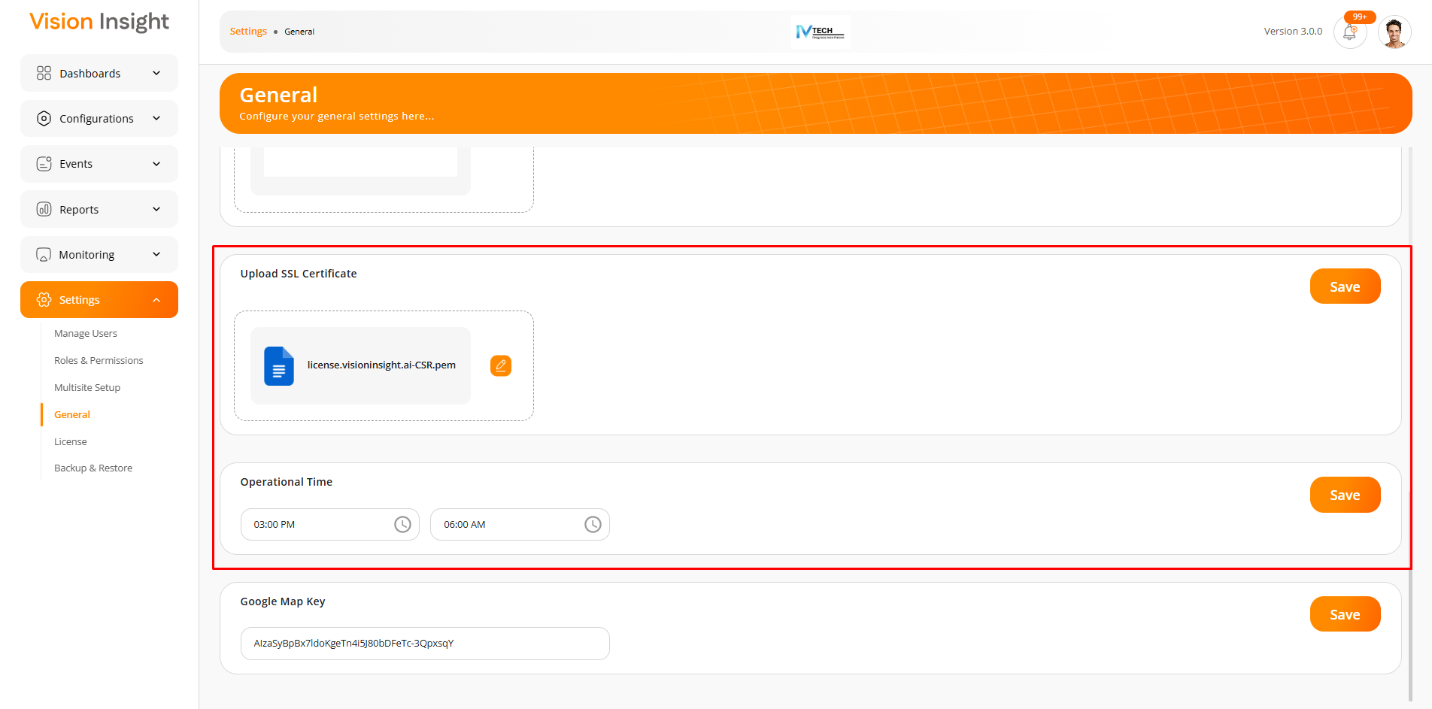

Configuration – Backup & Restore Page

This page will allow users to take a full backup of the application with data and restore it as per their need or situations.

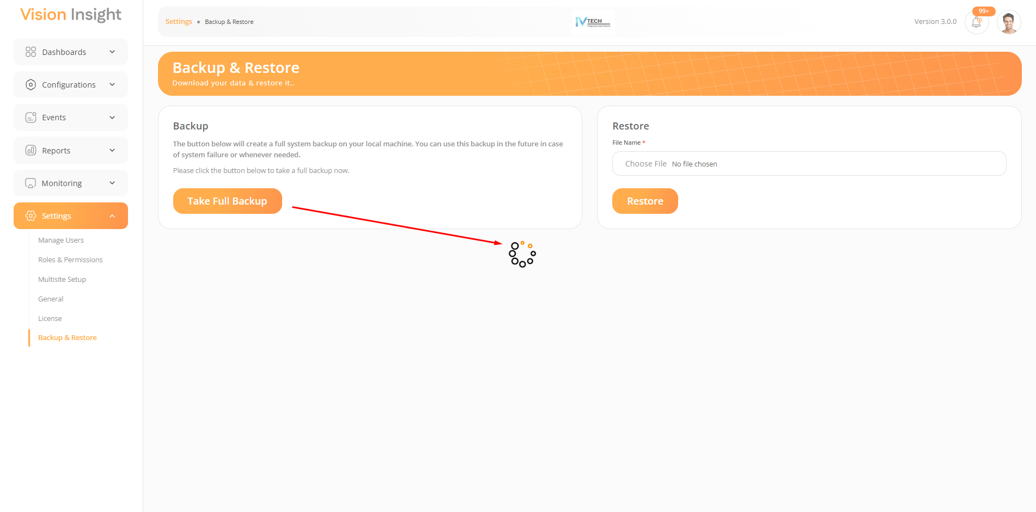
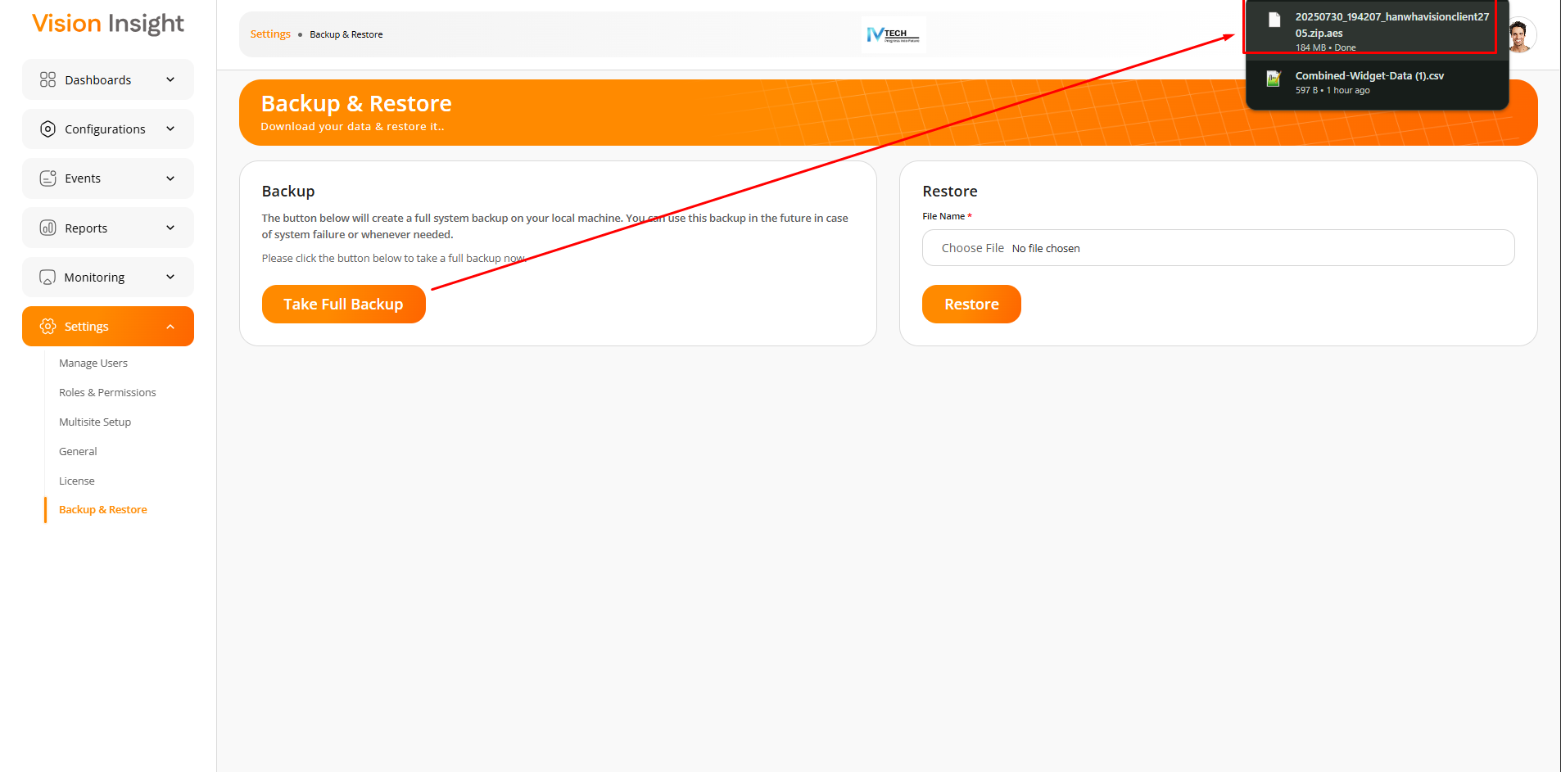
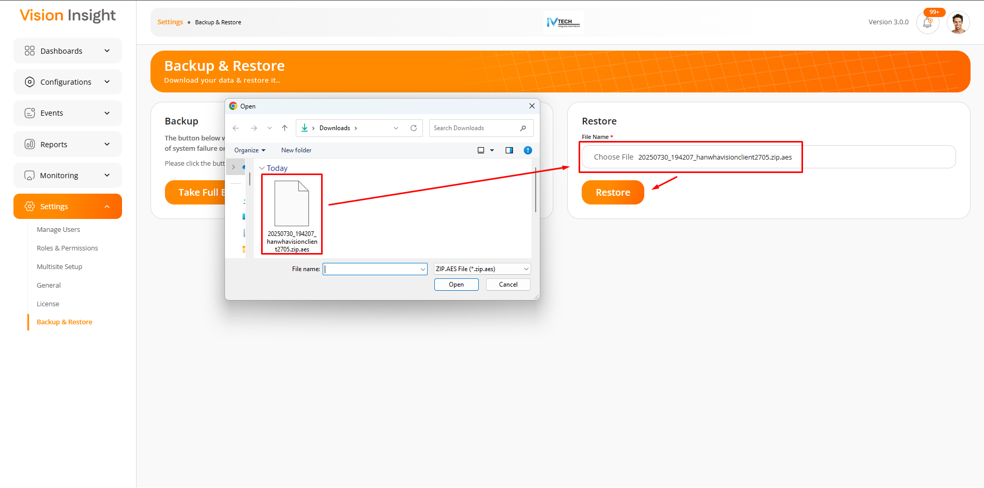

Alexa Integration

This feature allows users to give voice commands to an Alexa-enabled device, which will then trigger the system to open specific widgets on designated dashboards.

The system supports the following voice commands to open and close specific widgets within the application:

- Alexa, open [DashboardName] dashboard
- Alexa, show the [DashboardName] dashboard
- Alexa, go to the [DashboardName] dashboard
- Alexa, open [WidgetName] widget
- Alexa, show the [WidgetName] widget
- Alexa, go to the [WidgetName] widget
- Alexa, close [WidgetName] widget
- Alexa, hide the [WidgetName] widget
- Alexa, remove the [WidgetName] widget from the screen

Note: The development has been completed from our end, and we have already submitted a request to upload the required Alexa skills to the AWS Alexa Service so they can be accessed remotely. However, we are currently facing an issue on the AWS Alexa side and are awaiting their response. Once we receive a response, our development team will verify the integration and inform you accordingly.

Other Key Features

This includes following points:

- Support for Multilane Configuration:

This feature allows users to select up to an 8-lane configuration while setting up the camera for a specific zone.
Please note that the lane configuration must be enabled from the camera itself, as the system will only display the number of lanes that are activated on the camera.

Please find the attached screenshot below for your reference:
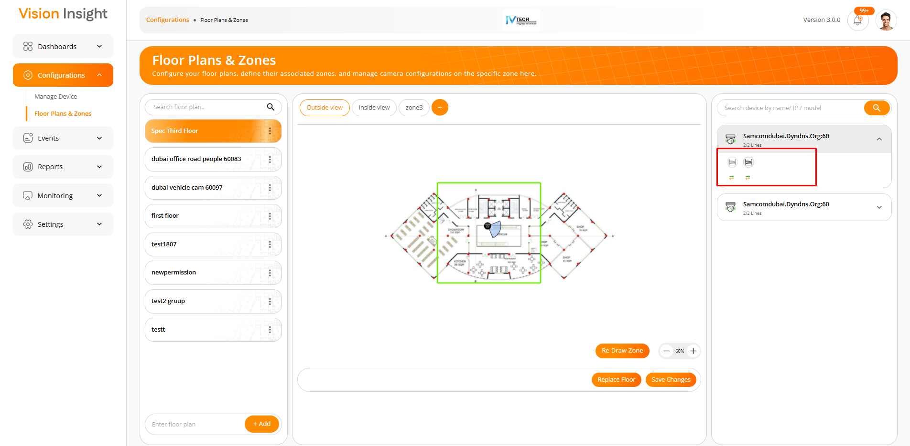

- Event Logs screen:

This feature allows users to view all generated events and search for specific events by applying filters.

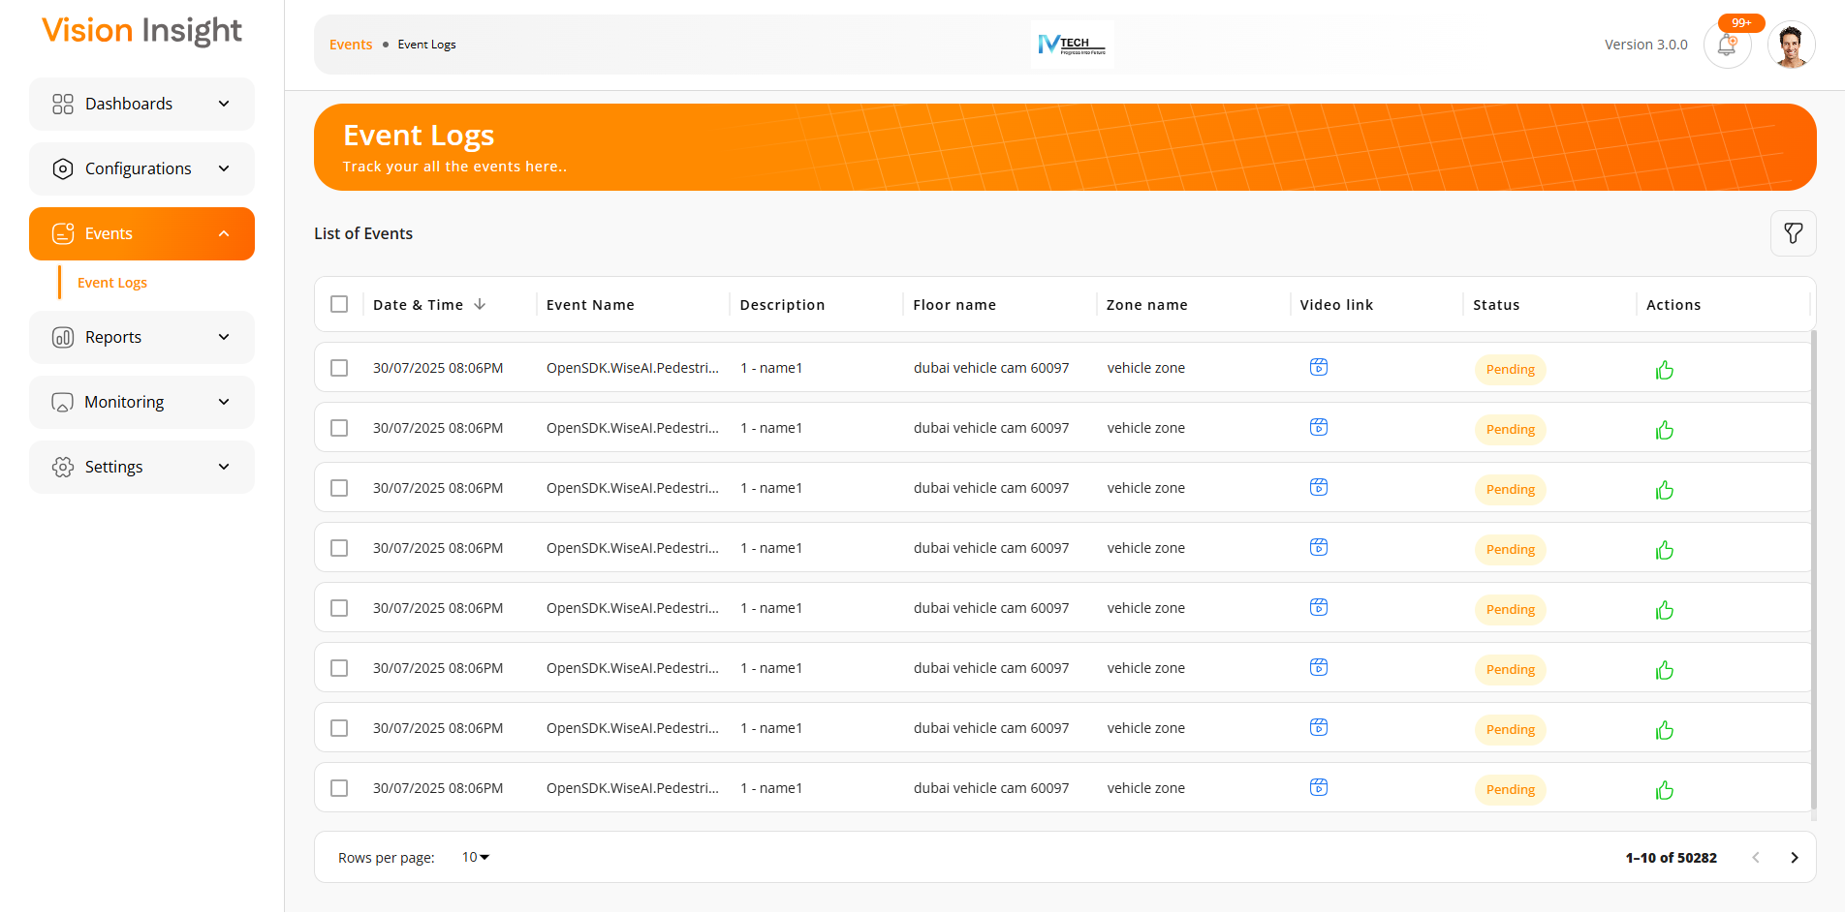
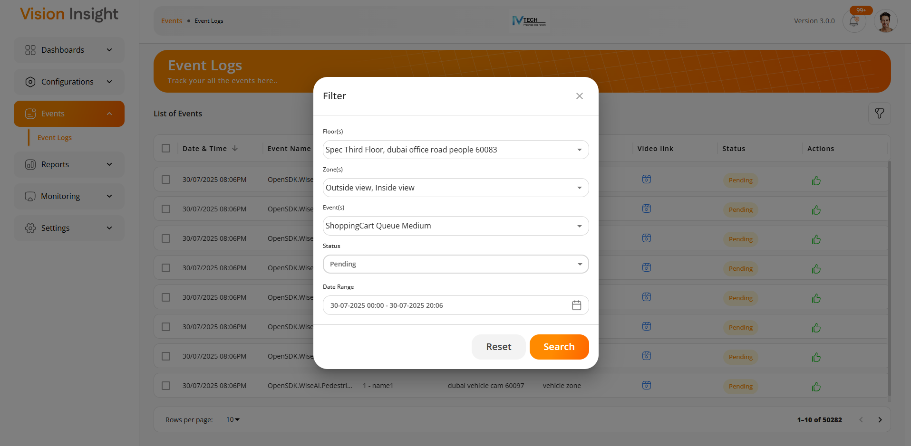
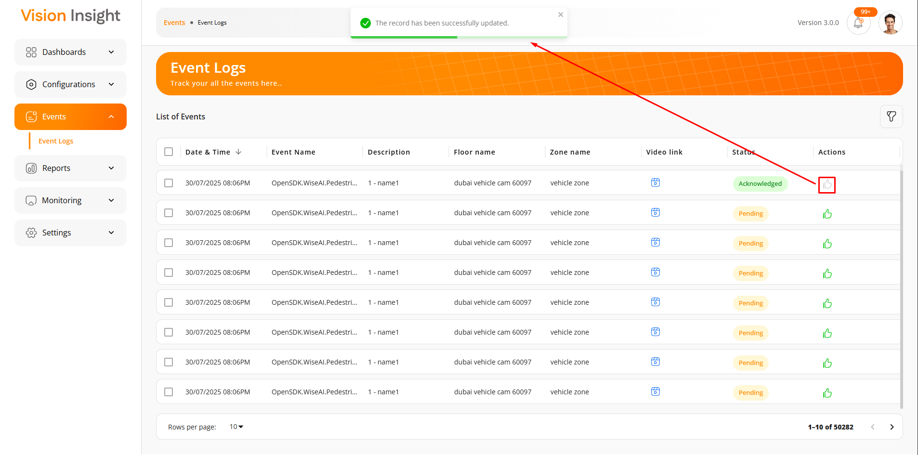

---- end of document ----

